Supplemental Information
Table S1 E. coli strains and plasmids

E. coli strain/Plasmid | Features | Ref.
Strain
GB05-dir | GB2005, araC-P_{BAD}-ETgA operon were inserted at the ybcC locus | [1]
GB08-red | GB2005, araC-P_{BAD}-αβrA operon were inserted at the ybcC locus | [2]
Plasmid
p15A-cm-tetO-tetR-hyg-ccdB | Cm^{r}, p15A origin | [3]
p15A-cm-P_{lipAB}-lipAB | Cm^{r}, p15A origin, P_{lipAB}-lipAB, | This study
pRK2-km-apra | Apra^{r}, Km^{r}, pRk2 origin | [4]
pRI | Km^{r}, pRk2 origin, P_{lipAB}-lipAB | This study
pRa | Km^{r}, pRk2 origin, P_{apra}-lipAB | This study
pBBR1-km | Km^{r}, pBBR1 origin | This study
pBI | Km^{r}, pBBR1 origin, P_{lipAB}-lipAB | This study
pBa | Km^{r}, pBBR1 origin, P_{apra}-lipAB | This study

Table S2 Oligonucleotide sequences

Name | Sequence (5′−3′) | Use
PG1-lipAB-A | tcgac atgacacggcgcgagacgtattgcggcgcagcgcgAA  GGCCGCGCTGTCGGTGAACGCTCTCTACTA | Amplify the cloning vector of p15A-cm
PG1-lipAB-S | gtatccgcaggtggccgatatcgtctggcggatggcgctgTGC  GGGGCGGTGAGACGTTGATCGGCACGTA
RK2-lipAB-A | atgctgcggcgcgcaagcgggcgcgatcgatccggtgaatCAC  TGAGCGTCTAGCGTTTG | Amplify the subcloning vector of pRk2-km
RK2-lipAB-S | gccgcgagcgagcaagaatcacgacgctctgcaacaatgcGC  TCGCCAGTCGATTGGCTGA
BBR1-lipAB-A | atgctgcggcgcgcaagcgggcgcgatcgatccggtgaatTC  GAAATCTCGTGATGGCA | Amplify the subcloning vector of pBBR1-km
BBR1-lipAB-S | gccgcgagcgagcaagaatcacgacgctctgcaacaatgcGT  GGAGGTAATAATTGACGA
P_{apra}-A | ccgccctcgccgccaccctggaacgcatcgatctgaccatAAT  CTGTACCTCCTTAAGTCAG | Amplify promoter P_{apra}.
P_{apra}-S | gatcgcgcccgcttgcgcgccgcagcatccgcgccgtcatAC  GCTCAGTGGAACGAGGTT
lipA F | GTGAACCTGATCGGCCACA | qPCR for lipA
lipA R | CGGTCGGATCGGTCTTCAG
rpoD F | AACCGTGGATGCTTGAGTAGTGC | qPCR for rpoD
rpoD R | TGCTTCTTCCGCCAAGTCAGT
Note: Underlined sequences are homology arms. Capital letter are the primers.

Fig S1 Pvu I restriction analysis of clones obtained in Fig 1. p15A-cm-P_{lipAB}-lipAB (A), pRI (B), pRa (C), pBI (D) and pBa (E). Marker: DL5000.
E
D
Fig S2 The expression levels of lipA determined by qPCR in strains PG1 containing different plasmids in PG medium in the presence of 1% olive oil. Error bars show standard deviations derived from three replicates.
500-
1000-
3000-
5000-
A
B
C
D
E
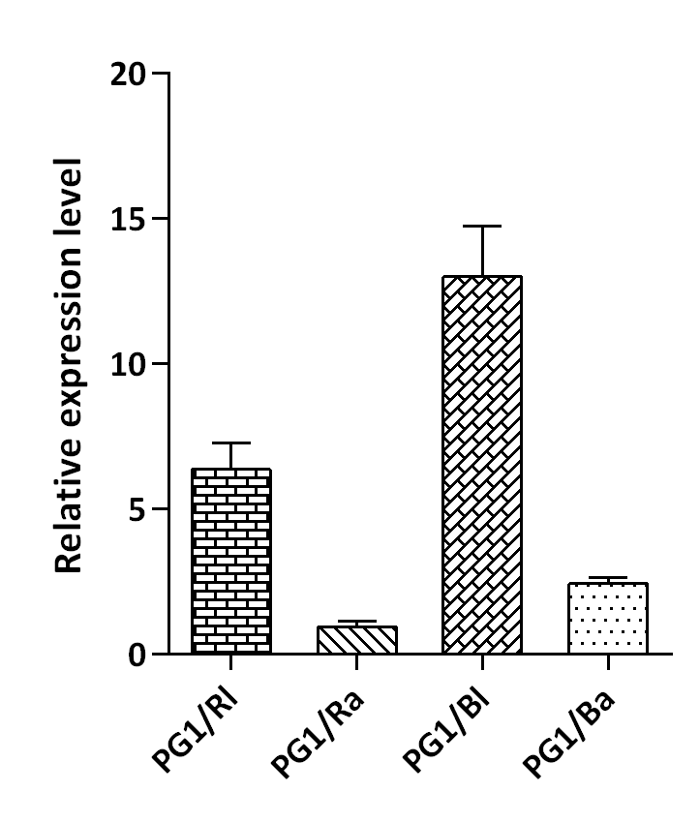
Supplementary References
1. Fu, J., et al., Full-length RecE enhances linear-linear homologous recombination and facilitates direct cloning for bioprospecting. Nat Biotechnol, 2012. 30(5): p. 440-6.
2. Fu, J., et al., A recombineering pipeline to make conditional targeting constructs. Methods Enzymol, 2010. 477: p. 125-44.
3. Wang, H., et al., RecET direct cloning and Redalphabeta recombineering of biosynthetic gene clusters, large operons or single genes for heterologous expression. Nat Protoc, 2016. 11(7): p. 1175-90.
4. Wang, X., et al., Discovery of recombinases enables genome mining of cryptic biosynthetic gene clusters in Burkholderiales species. Proc Natl Acad Sci U S A, 2018. 115(18): p. E4255-E4263.

